**­­­­­­­­A**

**PROJECT REPORT**

**ON**

# **CHARUSAT MEDICARE.**



­­­­­­

**SUBMITTED BY: GUIDED BY:**

**Aziz Moriswala – D22IT211 Dr. Chandrashekhar Goswami**

**Yash Kotiya – D22IT202**

**Aryan – D22IT214**

**B.Tech in Information Technology**

**Submitted To:**

**CHANDUBHAI S. PATEL INSTIUTE OF TECHNOLOGY**

**Changa**

**CHANDUBHAI S. PATEL INSTIUTE OF TECHNOLOGY**

**Changa**



# C E R T I F I C A T E

**This is to certify that Moriswala Aziz, Kotiya Yash & Aryan of** **B.Tech (3rd Semester) in Information Technology, Enrolment No: D22IT211, D22IT202 & D22IT214 have satisfactorily presented their project entitled “CHARUSAT Medicare.” for the term ending in November 2022.**

|  |  |
| --- | --- |
| **Signature Of Guide:** | **Department In-Charge:** |
| **Dr. Chandrashekhar Goswami** | **Dr. Parth Shah** |

**CHANDUBHAI S. PATEL INSTIUTE OF TECHNOLOGY**

**Changa**



# C E R T I F I C A T E

**This is to certify that Moriswala Aziz, Kotiya Yash & Aryan of B.Tech (3rd Semester) in Information Technology, Enrolment No: D22IT211, D22IT202 & D22IT214 have satisfactorily presented their project entitled “CHARUSAT Medicare.” for the term ending in November 2022.**

**DATE:**

**INTERNAL JURY: EXTERNAL JURY:**

**ACKNOWLEDGEMENT**

We take this opportunity to express our profound sense of gratitude and respect to all those who helped us throughout the duration of this project***.***

Firstly, we are extremely grateful to **Chandubhai S Patel Institute of Technology**, for providing us the excellent working environment to undergo our project.

We devote our success in this effort to our project guide **Dr. Chandrashekhar Goswami** for giving us the opportunity to undertake the project and providing crucial feedbacks that influenced us and provided opportunity to undertake the project work in the esteemed concern.

We are also deeply thankful to **Dr. Parth Shah, Head of Information Technology Department,** whose useful suggestions, gentle soothing attitude and right directions helped us a lot to learn in this project and also for her constant encouragement and support throughout the project.

Last, but not the least, we would like to extend our profound thanks to all our esteemed colleagues and friends at college level who helped us in the specific areas of this project.

## ABSTRACT

In our university there are several covid-19 hospitals are located. So, many medicines are not available at their medical store. Much of the medicines are we have to buy out of college. So we provide our website to get medicine easily and fast to the patient. India is currently undergoing increased urbanization and population growth. The existing health care facilities and health care personnel are not able to cater to the health care needs of the population. So, our website consists of people, institutions, and resources that deliver health care services to meet the health needs of people. The review showed that health website’s appearance has an important role in users view on its credibility. Considering the importance of visual structure of medical websites, there is an emergent need to develop a national guideline to obviate the problems of non-consistent, poor, or personalized design of medical websites.

**INDEX**

|  |  |  |  |
| --- | --- | --- | --- |
| **Sr. No.** |  | **Description** | **Page No.** |
| **1** |  | **Introduction** | **1** |
|  | 1.1 | Purpose | **2** |
|  | 1.2 | Scope | **2** |
| **2** |  | **System Requirement Specification** | **3** |
| **3** |  | **System Analysis** | **5** |
|  | 3.1 | Study of current system | **6** |
|  | 3.2 | Problem Statement | **6** |
|  | 3.3 | Requirement of new system | **7** |
|  | 3.4 | Feasibility Study | **8** |
| **4** |  | **Platform Detail** | **11** |
|  | 4.1 | Php – Intro | **12** |
|  | 4.2 | Php in Details | **13** |
|  | 4.3 | My SQL | **13** |
| **5** |  | **Design Specification Diagram** | **14** |
|  | 5.1 | Data flow diagram | **15** |
|  | 5.2 | ER diagram | **25** |
|  | 5.3 | Activity diagram | **28** |
|  | 5.4 | Use case diagram | **35** |
|  | 5.5 | Data Dictionary | **40** |
| **6** |  | **User Manual** | **47** |
| **7** |  | **Future Scope** | **48** |

|  |  |  |  |
| --- | --- | --- | --- |
|  | 7.1 | Limitations | **49** |
|  | 7.2 | Future Enhancement | **49** |
|  |  | **Conclusion** | **50** |
|  |  | **Bibliography** | **50** |

## Chapter 1: Introduction of Our Website

* 1. **Purpose**
  2. **Scope**

**Introduction**

* "A&T’s Medical website" is a website from which poor people who are not more eligible to take the medicine so we give them medicines in low rate/price, and we can sell items from website.
* So, they will get the medicine and can save more money than other established super medical stores. So, we are giving medicines in low price.
* So, from one website everyone can collect maximum seller and buyers and will try to improve our traditional medical products selling.
* A&T’s Medical Website is the website in which all the customers can get the medicines in fewer prices, easily and fast.
* So, it can helpful to their family in this expensive world.

##### 1.1 Purpose

* Develop a complete user interactive website
* Reduce manual work
* Provide better result & maximum satisfaction to customers
* Make fewer prices for poverty & for lower category people.
* Give online payment and item delivery facility.

##### 1.2 Scope

* This system is in web-based in which can only be accessed from the Intranet or the company internal network.
* Real time search functionality.
* Real time payment options for buyer and seller.

**Chapter 2: SYSTEM REQUIREMENT SPECIFICATION**

### Software Requirement

|  |
| --- |
| **Software Specification** |
| Client on Internet  Web Browser(any),  Windows Operating System  Data Base Server MY SQL  JavaScript  HTML,CSS  Development End  PHP  OS(Windows 7) |

Software Interface:

Client on Internet: Web Browser, Operating System (Windows)

Web Server: XAMP

Data Base Server: MY SQL.

Development End: PHP:

MY SQL, Operating System (Windows 7) Web Server.

Communication Interface:

Client on Internet will be using HTTP/HTTPS protocol.

**Chapter 3: SYSTEM ANALYSIS**

### 3.1 Study of current system

### 3.2 Problem Statement

### 3.3 Requirement of new system

### 3.4 Feasibility Study

#### 3.1 Study of Current System

* Existing system is based on manual work and all the process are done manually.
* Some system collects the data manually.
* They store all the information as a report in files.

#### Technologies:-

* Web Application
* Front-End: HTML, CSS, JAVASCRIPT
* Back-End: PHP
* The changes in technologies, management, etc., and Changes in organization design and structure affecting man power demand.

##### 3.2 Problem and Weakness of Current System:-

* Not enough available marketing platforms.
* Not good price to take in selling any product.

##### 3.3 Requirement of New System

**Input data:**

There will be two types of data entry:

* Data entered by Buyers and Sellers: They both are supposed to enter their personnel information at the time of Registration, and product information at the time of adding new product for sell or purchase.
* Data entered by Administrator: This will be regarding updating data for e.g. adding or deleting products, categories, countries, states, etc.

**Output data:**

* One of the outputs from the system will be the information regarding the buyers and sellers.
* Information about the handy craft products.
* Report will be generated as per order.

**Functions to be performed:**

* By Buyers:

Enter and edit required data

Enter and edit recycle product requirements

Send and Check the mail • By Sellers:

Enter and edit required data

Enter and edit recycle product details

Send and Check the mail • By Administrator:

Controlling the access to the application.

Enter master information

Edit/delete master information

**Performance bounds:**

Following are the performance requirements for the system to be developed:

* Minimization of time required for maintain the data.
* Display of information regarding the recycle products.
* Maintaining data integrity.
* Minimization of data loss as well as the effort required to maintain the data.
* Well-designed user interface.
* Maintaining consistency of screen layouts.
* Secure login to maintain integrity of the system.
* Timely updates of data.

**Constraints:**

Following are the constraints identified that must be followed during the development of the system:

* **Time constraint:** The time given to develop the system was about 2 months. The total time required to develop and implement the system would not fit in the time given.
* **Technology and tools constraints:** Constraints imposed by development of the system using a particular technology and tool requires a deep knowledge in it, which takes time to study.
* **Personal constraints:** The constraint imposed by the skills possessed by me.

**Reliability:**

The system should be reliable in the following areas:

* Integrity of data should be maintained, requiring the atomicity of transactions.
* Data maintenance should be easy.
* Integrity of the system should be maintained, requiring a tight login security so that only the authorized user is allowed to perform a transaction.
* Data is stored in my sql which has good security the capacity of storing data is high.

##### 3.4 Feasibility Study

* A feasibility study is undertaken to determine the possibility or probability of either improving the existing system or developing a completely new system.
* It helps to obtain an overview of the problem and to get rough assessment of whether feasible solution exists.
* This is essential to avoid committing large resources o project and then report on it later.

**Need for Feasibility Study:**

The feasibility study is needed to

* Answer the question whether a new system is to be installed or not?
* Determine the potential of the existing system.
* Improve the existing system.
* Know what should be embedded in the new system.
* Define the problems and objective involved in a project.
* Avoid costly repairs a later stage when the system is implemented.
* Avoid crash implementation of a new system.
* Avoid the ‘Hardware Approach’ i.e. getting a computer first and then deciding how to use it.
* There are three aspects in feasibility study portion of the preliminary investigation. o Technical feasibility o Economic feasibility o Operational feasibility.

1. **Technical Feasibility:**
   * Technical Feasibility determines whether the work for the project be done with the present equipment, current procedures, existing software's technology and available personnel?
   * If new technology is needed then what alternatives will be needed in the present structure and work ethos?
   * This will require a close examination of the present system.

The technical feasibility should ask questions related to:

o Adequacy of available technology.

o Adequacy of hardware.

o Adequacy of computer.

o Operating time and support facilities, etc.

* + Technical feasibility determines whether the technology needed for the proposed system is available and how it can be integrated within the “Task Management System” and technical evaluation must also assess whether the existing system can be upgraded to use the new technology and whether the “Task Management System” has the expertise to use it.
  + The technical feasibility in the proposed system deals with the technology used in the system. It deals with the hardware and software used in the system whether they are of latest technology or not. It happens that after a system is prepared a new technology arises and the user wants the system based on that technology. Thus it is important to check the system to be technically feasible.
  + The minimum memory requirement is 2MB of RAM while 4MB is better to have for better performance.
  + As far as software is concerned, licensed version of MySQL and PHP should be installed on the server.

There should be printer attached to the network for printing of various reports.

1. **Economic feasibility:**
   * Economic feasibility looks at the financial aspects of the project. Economic feasibility concerns with the returns from the investments in a project. It determines whether it is worthwhile to invest the money in the proposed system. It is not worthwhile spending a lot of money on a project for no retuTo carry out an economic feasibility for a system, it is necessary to place actual money value against any purchases or activities needed to implement the project.
   * The advocate plans to acquire the necessary hardware and software require for the system and there is no hindrance whether economical or otherwise towards its purchase. A brief description of the hardware and software required in the system is given later in the report.
2. **Operational feasibility:**
   * Operational feasibility covers two aspects. One is the technical performance aspect and other is the acceptance within the “GIFT OF HAND”. Operational feasibility determines how the proposed system will fit in the current operations and what, if any job restructuring and retraining may be needed to implement the system.

## 4. PLATFORM DETAIL

### 4.1 PHP Introduction

### 4.2 PHP in Detail

### 4.3 MY SQL

**4.1 PHP Introduction**

PHP started out as a small open source project that evolved as more and more people found out how useful it was. Rasmus Lerdorf unleashed the first version of PHP way back in 1994.

* PHP is a recursive acronym for "PHP: Hypertext Preprocessor".
* PHP is a server side scripting language that is embedded in HTML. It is used to manage dynamic content, databases, session tracking, even build entire e-commerce sites.
* It is integrated with a number of popular databases, including MySQL, PostgreSQL, Oracle, Sybase, Informix, and Microsoft SQL Server.
* PHP is pleasingly zippy in its execution, especially when compiled as an Apache module on the UNIX side. The MySQL server, once started, executes even very complex queries with huge result sets in record-setting time.
* PHP supports a large number of major protocols such as POP3, IMAP, and LDAP. PHP4 added support for Java and distributed object architectures (COM and CORBA), making n-tier development a possibility for the first time.
* PHP is forgiving: PHP language tries to be as forgiving as possible.
* PHP Syntax is C-Like. **Common uses of PHP**
* PHP performs system functions, i.e. from files on a system it can create, open, read, write, and close them.
* PHP can handle forms, i.e. gather data from files, save data to a file, through email you can send data, return data to the user.
* You add, delete, modify elements within your database through PHP.
* Access cookies variables and set cookies.
* Using PHP, you can restrict users to access some pages of your website.
* It can encrypt data.

#### Characteristics of PHP

Five important characteristics make PHP's practical nature possible −

* Simplicity • Efficiency • Security
* Flexibility
* Familiarity

##### 4.2PHP MySQL Database

**What is MySQL?**

* MySQL is a database system used on the web
* MySQL is a database system that runs on a server
* MySQL is ideal for both small and large applications
* MySQL is very fast, reliable, and easy to use
* MySQL uses standard SQL
* MySQL compiles on a number of platforms
* MySQL is free to download and use
* MySQL is developed, distributed, and supported by Oracle Corporation
* MySQL is named after co-founder Monty Widenius's daughter: My

The data in a MySQL database are stored in tables. A table is a collection of related data, and it consists of columns and rows.

Databases are useful for storing information categorically. A company may have a database with the following tables:

* Employees
* Products
* Customers
* Orders

## 5. DESIGN SPECIFICATION DIAGRAM

### 5.1 Data flow diagram

### 5.2 ER diagram

### 5.3 Activity diagram

### 5.4 Use case diagram

### 5.5 Data Dictionary

#### 5.1 Data Flow Diagram

* Data flow diagram is a graphical tool used to describe and analysis the movement of data through a system-manual or automated including the Processes stores the data, and delays in the system.
* Data flow diagrams are the central tool and basis from which other components are developed.
* The transformations of the data from input to output through the Processes May be described logically and independently of the physical components Associated with the system. They are termed logical data flow diagrams.
* In contrast, physical data flow diagrams show the actual Implementation and the movement of data between people departments and workstations.
* The simple notations are easily understood by users and business Persons who are part of the process being studied. Therefore, analysts can work With Users and actually involve them in the study of data flow diagrams.
* Users can make suggestions for modifications of the diagrams to More Accurately Described the business activity. They can also examine the charts and spot Problems quickly so that they can be corrected before other design work begins. If problems are not found early in the development process they will be very difficult to correct when they are noticed. Avoiding mistakes early May even prevent system failure.
* Data flow analysis permits analysts to isolate areas of interest in the institution and study them by examining the data that enter the process and seeing how they are changed when they are changed when they leave the process. As analyst gather acts and details their increased understanding of the process leads them to ask questions about specifications of the process which leads to still additional investigation as the area of investigation is broken into successively lower level details until all the essential components and their interrelations can be understood.
* A comprehensive system investigation produces sets of many data flow diagrams some providing overviews of major processes and others going into great details to show data elements, data stores, and processing steps for specific components of a larger system. If analysts want to review the overall system later, they use the higher-level overview diagrams. However if they are interested in studying one particular they use the data flow diagram for that lower process.
* The levels of data flow diagrams can be compared to highway and street Maps that you might use when traveling in an unfamiliar area you first use a national map, showing major highways and cities. As you near the city you are visiting you need a more detailed map showing the major parts of the city and the access roads. After you reach the area of the city you want, a detailed street map that shows even important landmarks, such as bridges and buildings, is especially helpful. This much detail is. Essential when you are first starting on the trip and attempting to understand the lay of the land.

•

Data

flow

diagrams

are

used

in

the

same

way.

They

are

developed

and

used

progressively

from

the

general

to

the

specific

for

the

system

of

interest.

The

data

flow

diagram

covers

all

the

processes

and

data

storage

area,

which

takes

place

during

any

transaction

in

the

system.

The

data

flow

diagrams

are

functionally

divided

into

Context

level

(

Zero

level)

and

First

level

data

flow

diagrams.

**Symbols**

**used**

**in**

**DFDs:**

(1)

Process:

Here

flow

of

data

is

transformed.

E.g.

Registering

Student,

etc.



(2)

External

Entity:

A

source

or

destination

of

data

which

is

external

to

the

system.

E.g.

Principal

Etc.

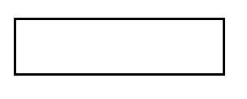

(3)

A

data

flow:

It

is

packet

of

data.

It

may

be

in

the

form

of

document,

letter

etc.

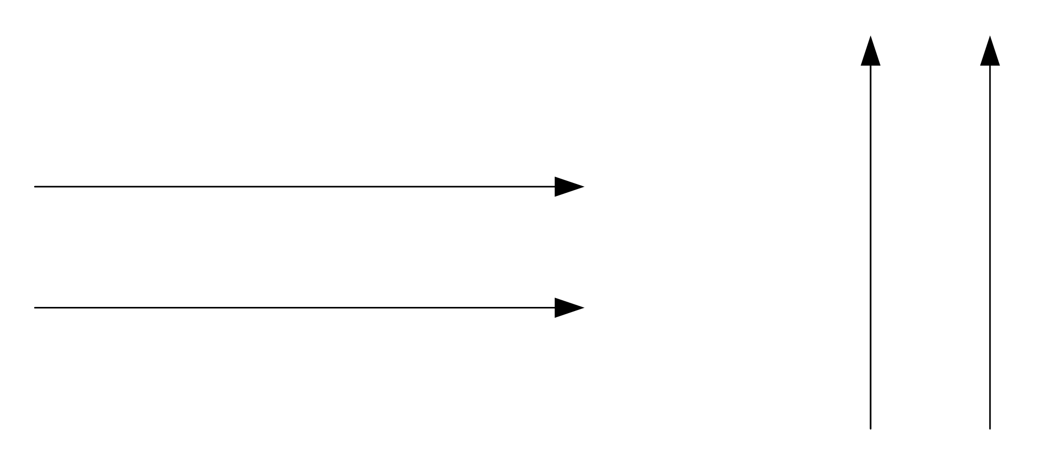

(4)

Data

store:

Any

store

data

but

with

no

reference

to

the

physical

method

of

storing.

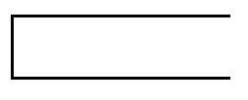

**5.1.1 Data Flow Diagram:**

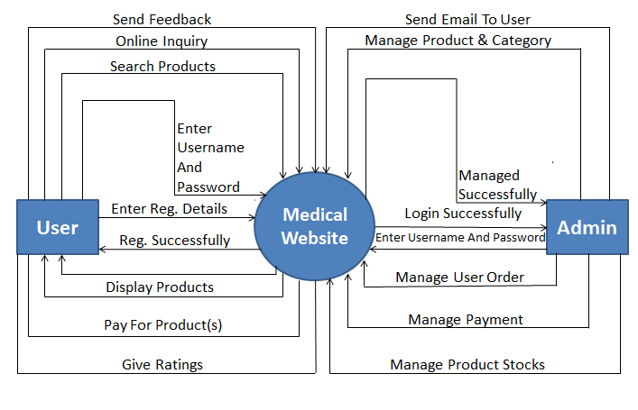

Figure 5.1.1

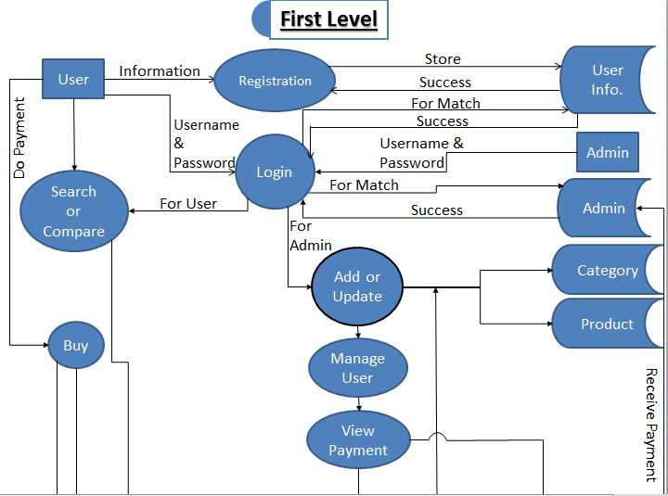

Store Payment Data

Payment

5.1.2

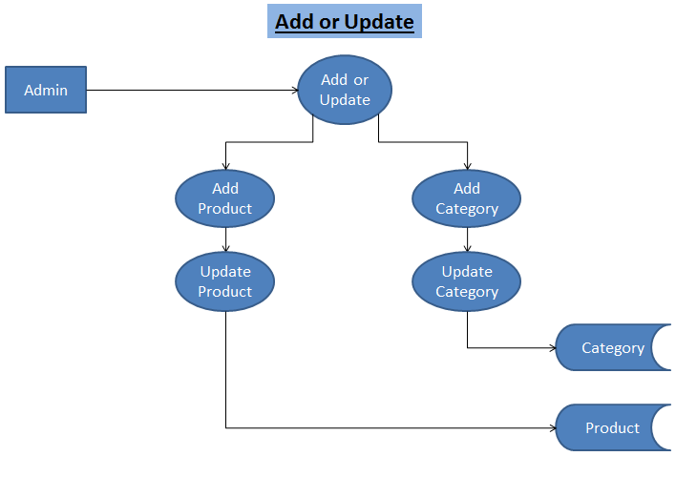

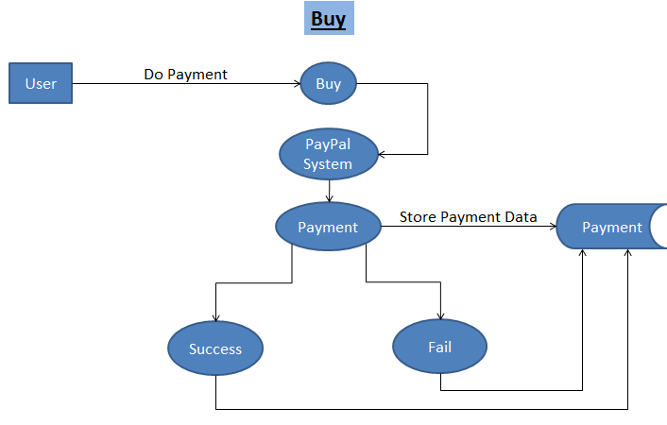

#### 5.2 ER-diagram

• In software engineering, an entity-relationship model (ER model for short) is an abstract and conceptual representation of data. Entity-relationship modeling is a database modeling method, used to produce a type of conceptual schema or semantic data model of a system, often a relational database, and its requirements in a top-down fashion. Diagrams created by this process are called entity-relationship diagrams or ER diagrams. E-R Diagram mainly consists of:

o Entity

o Attributes

o Relationships

* An entity may be defined as a thing which is recognized as being capable of an independent existence and which can be uniquely identified. An entity is an abstraction from the complexities of some domain. When we speak of an entity we normally speak of some aspect of the real world which can be distinguished from other aspects of the real world.
* An entity may be a physical object such as a house or a car, an event such as a house sale or a car service, or a concept such as a customer transaction or order. Although the term entity is the one most commonly used, following Chen we should really distinguish between an entity and an entity-type. An entity-type is a category. An entity, strictly speaking, is an instance of a given entity-type. There are usually many instances of any entity-type. Because the term entity-type is somewhat cumbersome, most people tend to use the term entity as a synonym for this term.
* A relationship captures how entities are related to one another. Relationships can be thought of as verbs, linking two or more nouns.

Generally we use this symbols in er-diagram

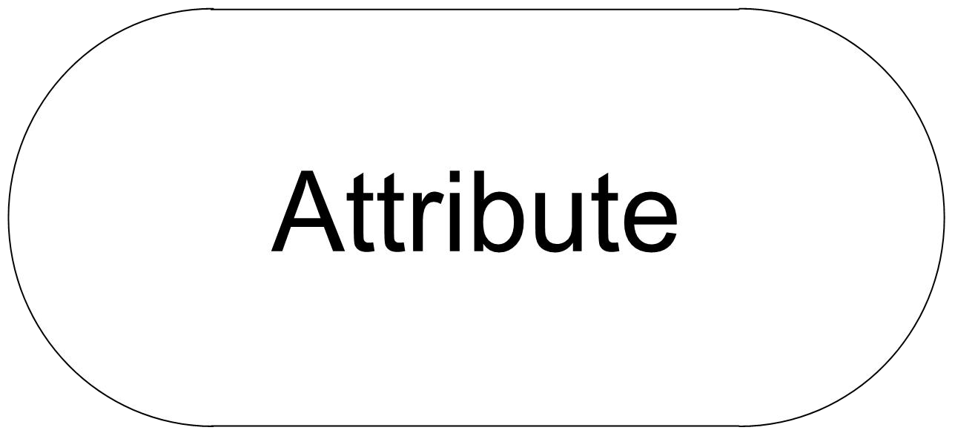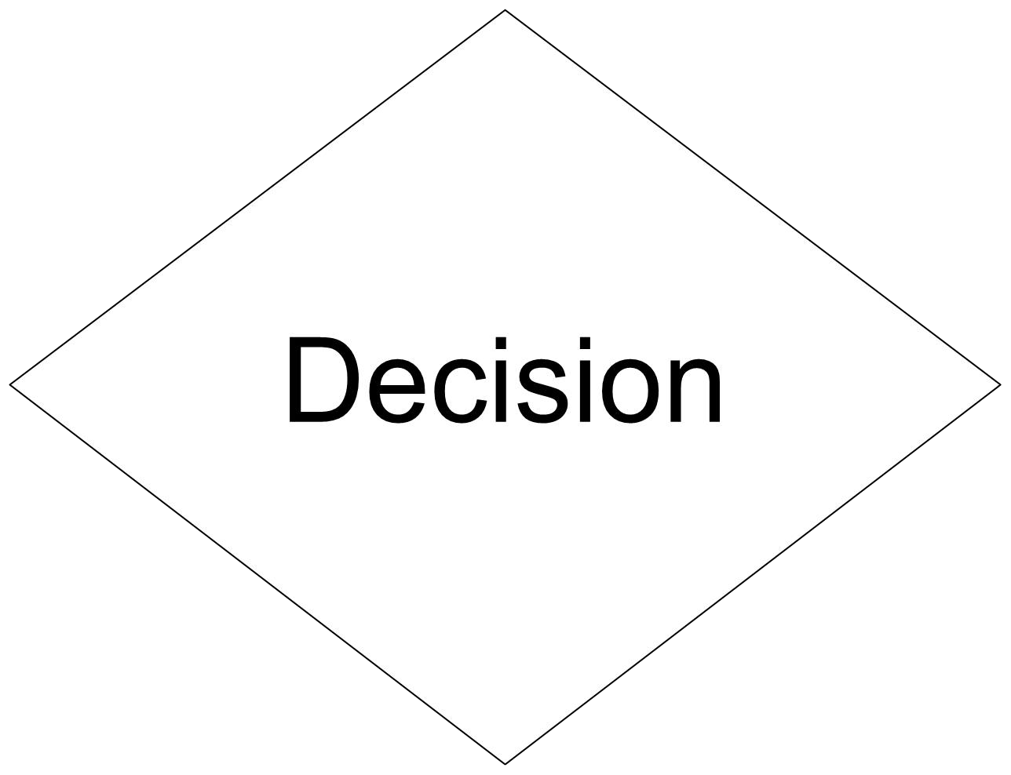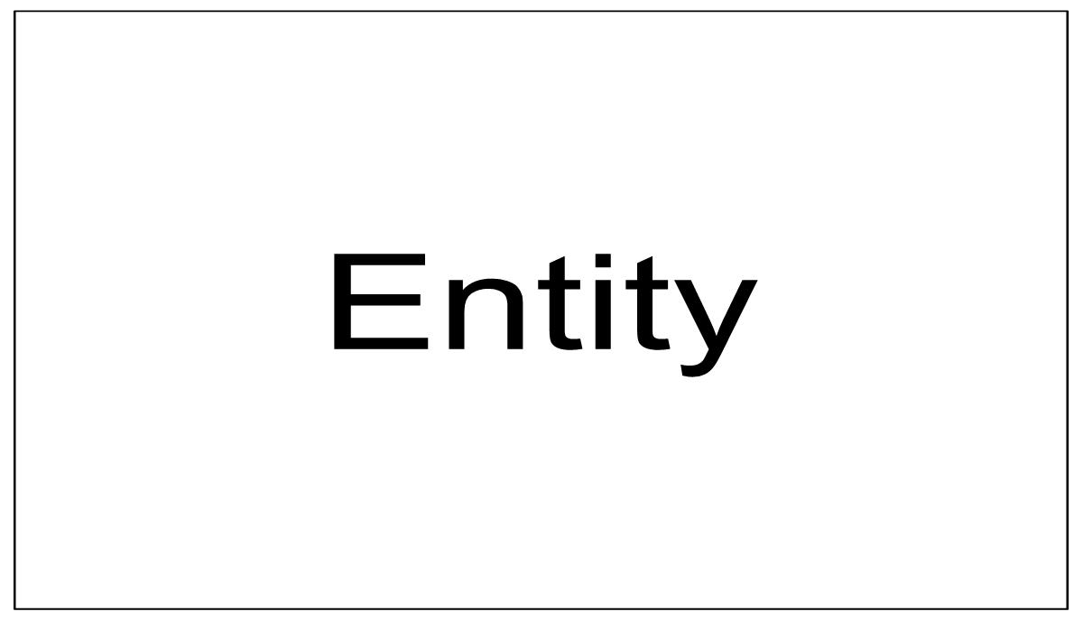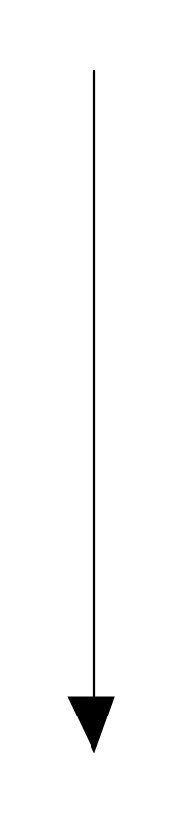

**Connection**

**E-R Diagram**

**5.3 Activity Diagram:**

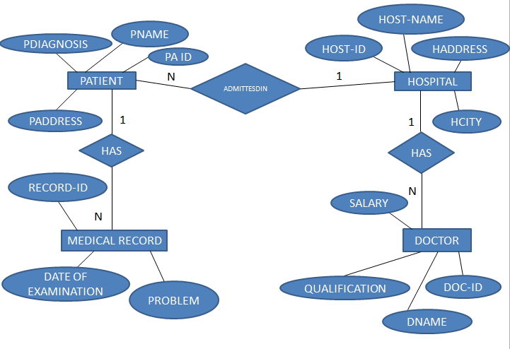



5.3.1

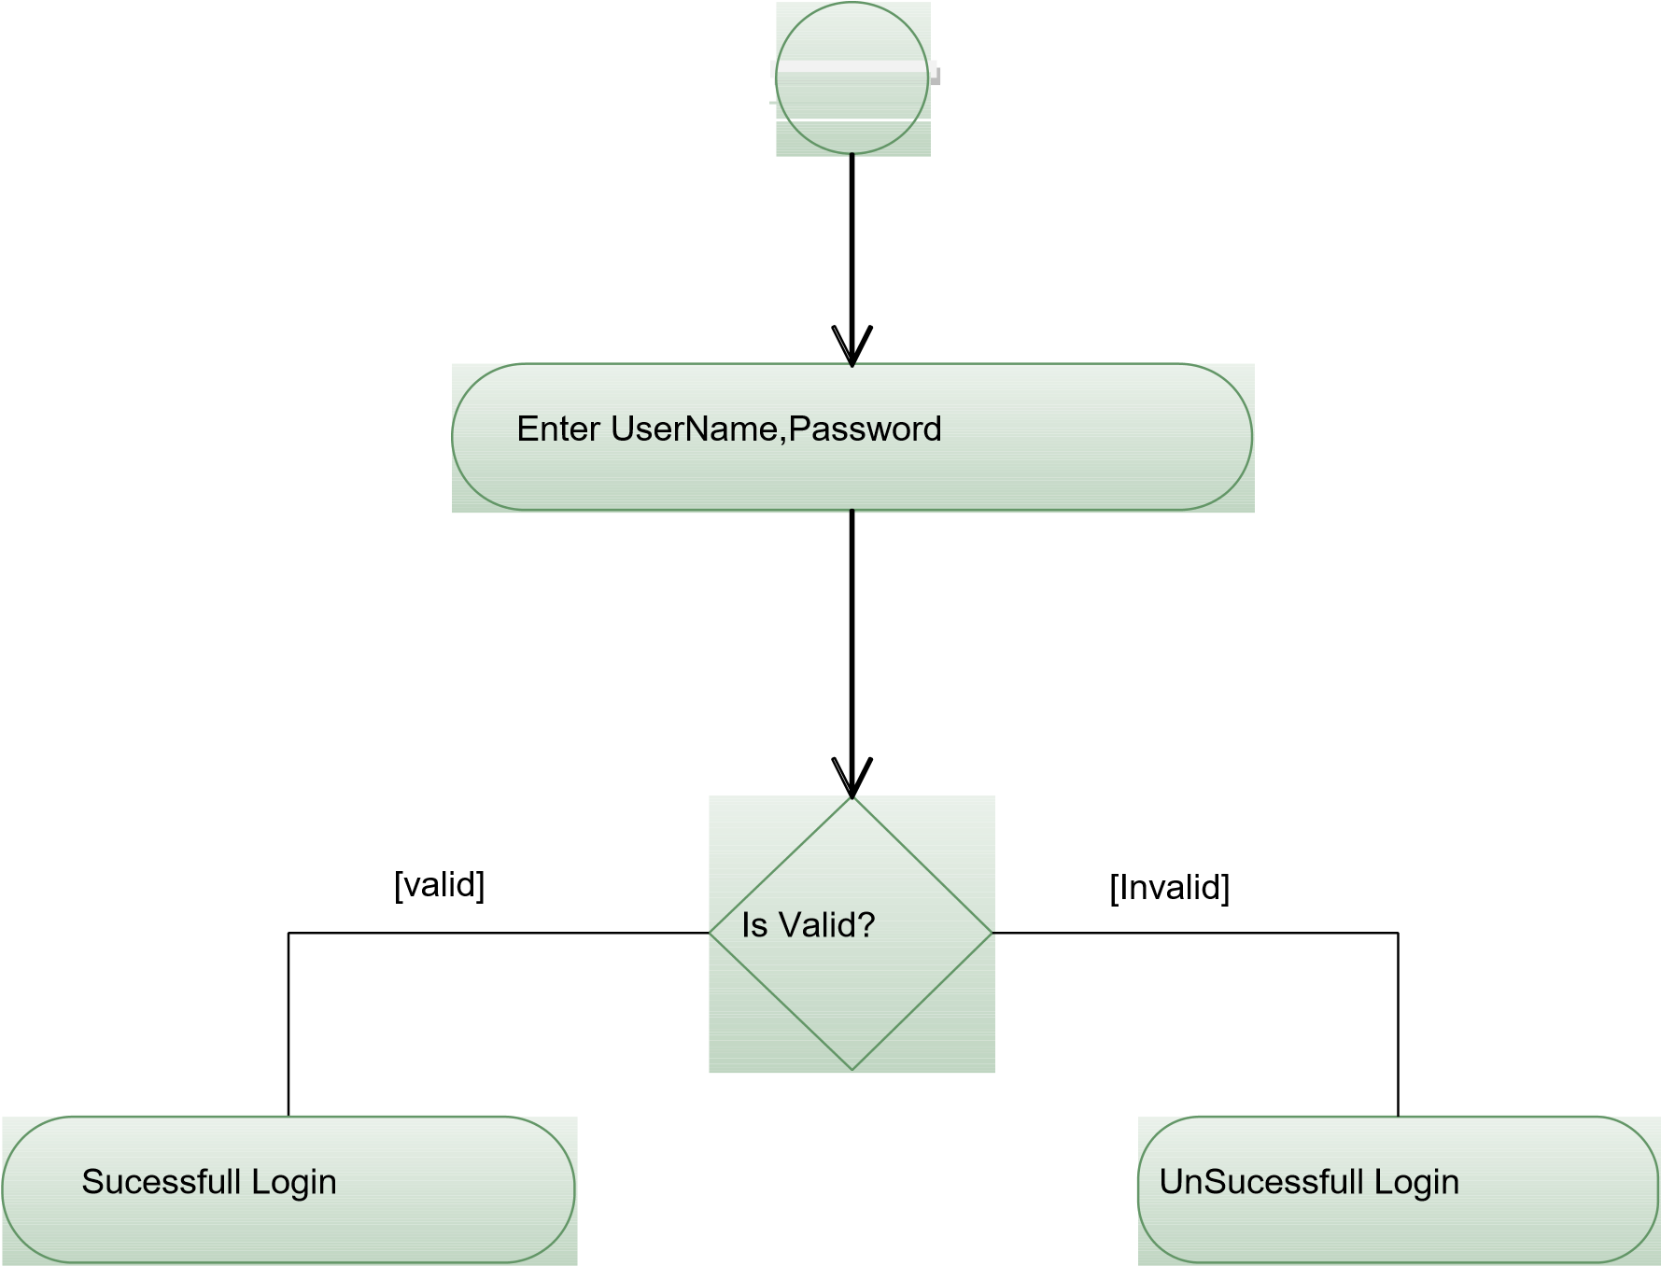**Activity Diagram for Login**

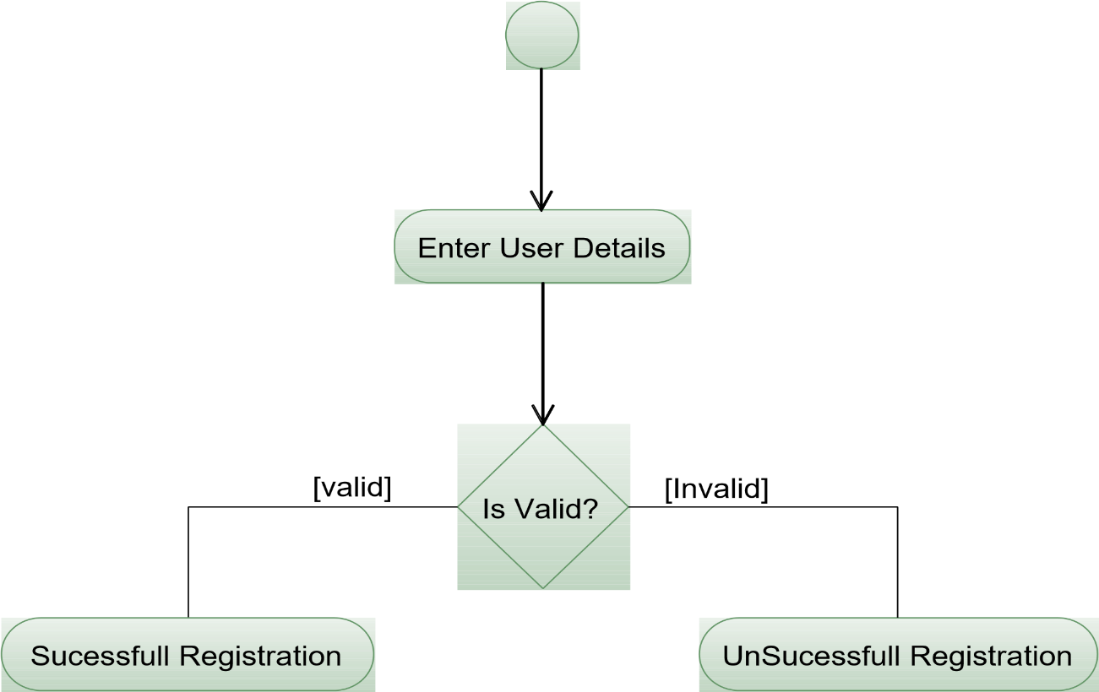

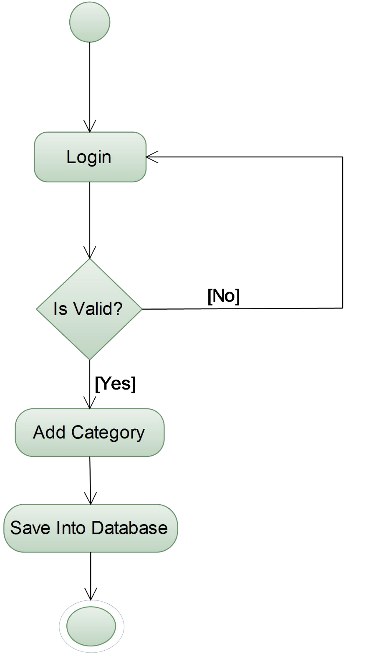**Activity Diagram for Admin- Add Handy Craft Category:**

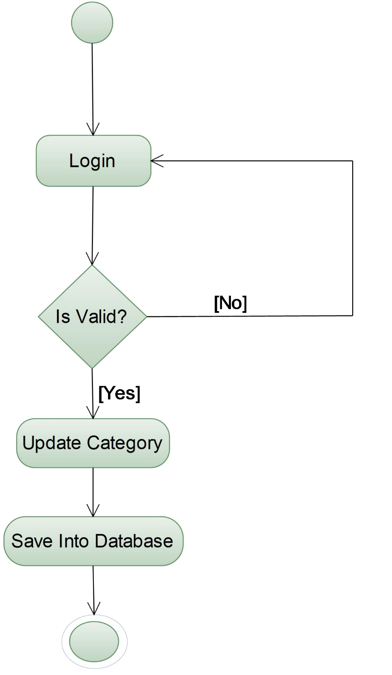**Activity Diagram for Update Handy Craft Category:**

5.3.4

**Activity Diagram for Delete HandyCraft Category:**

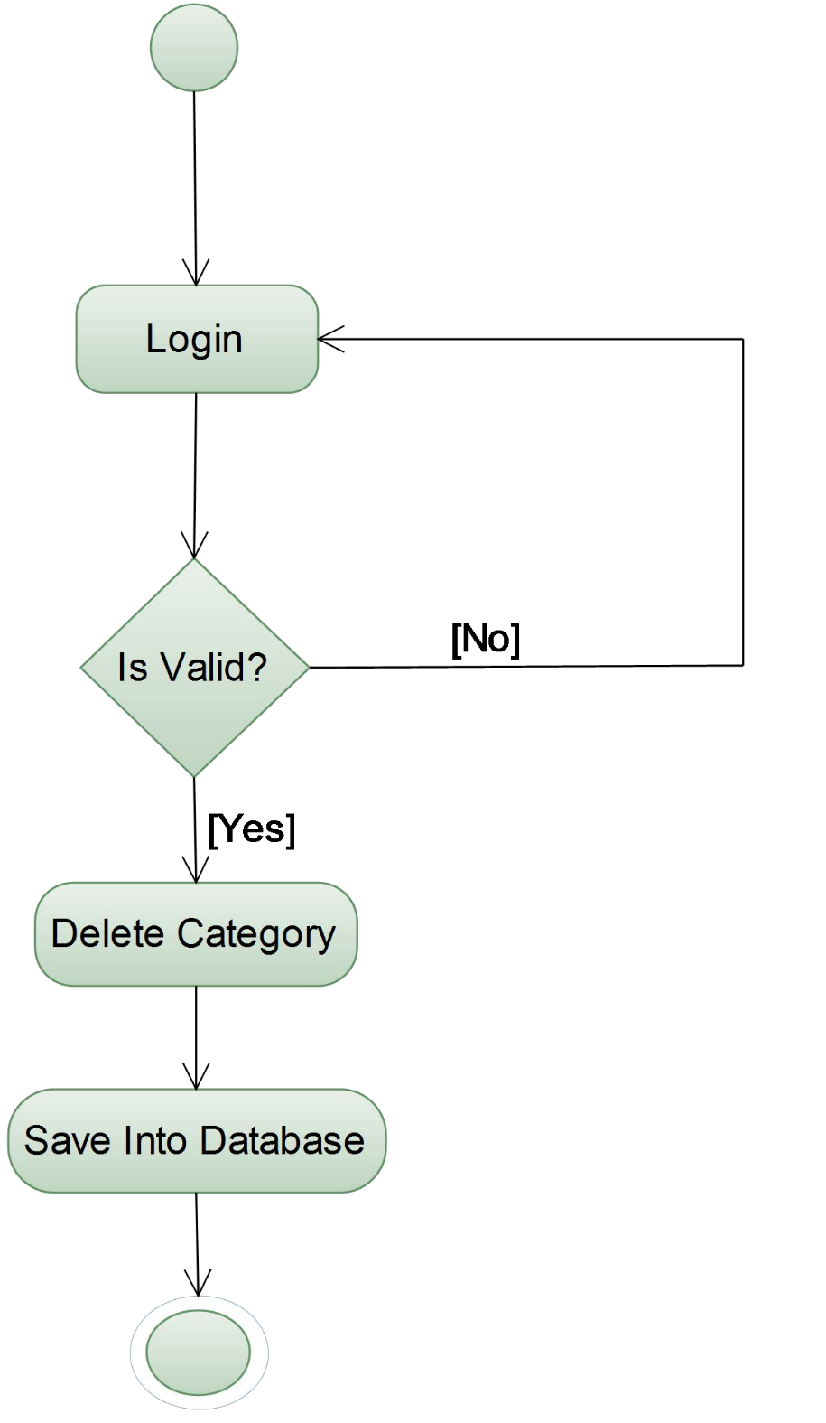

5.3.5

**Activity Diagram for Recycle Product:**

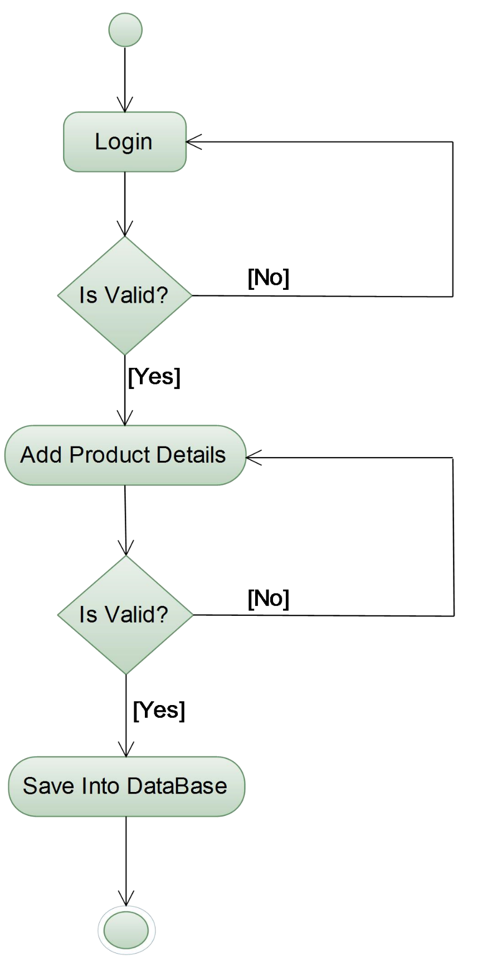

5.3.6

**Activity Diagram for Buy Product:**

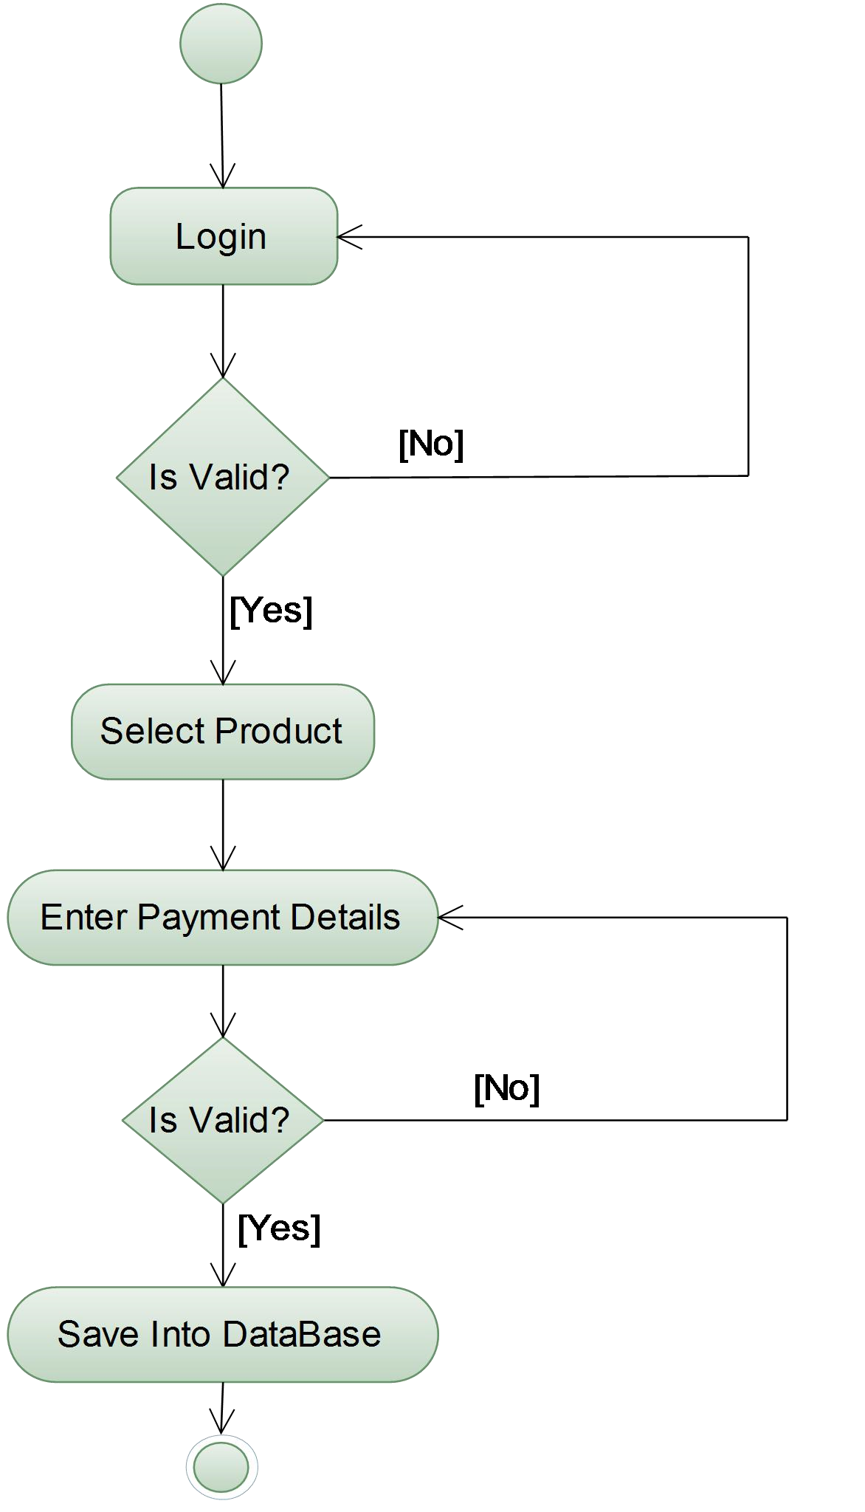

5.3.7

#### 5.4 Use case Diagram

* A use case diagram in the Unified Modelling Language (UML) is a type of behavioural diagram defined by and created from a Use-case analysis. Its purpose is to present a graphical overview of the functionality provided by a system in terms of actors, their goals (represented as use cases), and any dependencies between those use cases.
* The main purpose of a use case diagram is to show what system functions are performed for which actor.
* Interaction among actors is not shown on the use case diagram. If this interaction is essential to a coherent description of the desired behaviour, perhaps the system or use case boundaries should be re-examined. Alternatively, interaction among actors can be part of the assumptions used in the use case.
* **Use cases**
* A use case describes a sequence of actions that provide something of measurable value to an actor and is drawn as a horizontal ellipse.
* **Actors**
* An actor is a person, organization, or external system that plays a role in one or more interactions with the system.
* **System boundary boxes (optional)**
* A rectangle is drawn around the use cases, called the system boundary box, to indicate the scope of system. Anything within the box represents functionality that is in scope and anything outside the box is not.
* **SYMBOLS USED IN USE CASE DIAGRAMS:**

Actor:

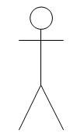

Use case:

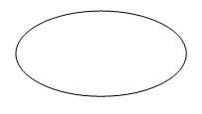

**Use Case Diagram: for user**

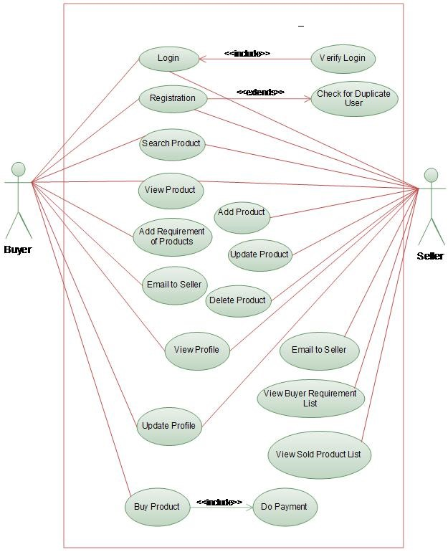

5.4.1

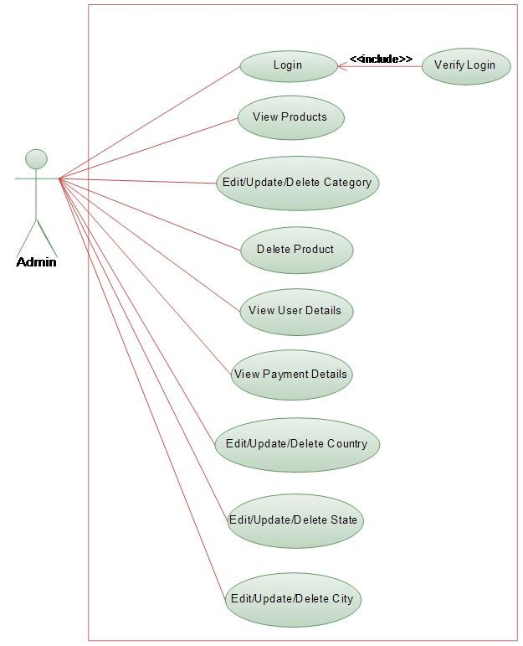**Use Case Diagram: For Admin**

#### 5.5 Data Dictionary

* **Table:** UserInfo
* **Description:** Used to store User information

|  |  |  |  |
| --- | --- | --- | --- |
| Column Name | Data Type | Constrains | Description |
| Userid | Int | Primary Key | User Id |
| Fname | varchar(50) | Not Null | First name of User |
| Lname | varchar(50) | Not Null | Last name of User |
| Gender | varchar(50) | Not Null | Gender of User |
| Dob | varchar(50) | Not Null | Date of Birth |
| Username | varchar(50) | Not Null | User name |
| Password | varchar(50) | Not Null | Password of User |
| Address | Varchar(MAX) | Not Null | Address of User |
| Phoneno | varchar(50) | Not Null | Mobile no of User |
| Emailid | varchar(50) | Not Null | E-mail id of User |

* **Primary Key:** userid
* **Table:** Admin
* **Description:** Used to store Admin information

|  |  |  |  |
| --- | --- | --- | --- |
| Column Name | Data Type | Constrains | Description |
| Adminid | Int | Primary Key | Admin Id |
| Adminname | varchar(50) | Not Null | Admin name |
| Password | varchar(50) | Not Null | Password of Admin |
| Phoneno | varchar(50) | Not Null | Mobile no of  Admin |
| Emailid | varchar(50) | Not Null | E-mail id of Admin |

* **Primary Key:** adminid
* **Table:** Category
* **Description:** Used to store the information of Category

|  |  |  |  |
| --- | --- | --- | --- |
| Column Name | Data Type | Constrains | Description |
| Catid | Int | Primary Key | Category Id |
| Catname | varchar(50) | Not Null | Category name |

* **Primary Key:** catid
* **Table:** Product
* **Description: Product detail of different Sellers.**

|  |  |  |  |
| --- | --- | --- | --- |
| Column Name | Data Type | Constrains | Description |
| ProductId | Int | Primary Key | Product Id |
| CatId | varchar(50) | Not Null | f. k. |
| ProductName | varchar(50) | Not Null | Name of Product |
| SellerId | varchar(50) | Not Null | f.k. |
| Description | varchar(500) | Not Null | Food description |
| imageName | Varchar(50) | Not Null | Imagename of  Product |

* **Primary Key:** product id
* **Table:** Seller

|  |  |  |  |
| --- | --- | --- | --- |
| Column Name | Data Type | Constrains | Description |
| SellerId | Int | Primary Key | p.k. |
| Seller_Name | varchar(50) | Not Null | Name |
| Address | varchar(50) | Not Null | address |
| Phoneno | varchar(50) | Not Null | Mobile no |
| Emailid | varchar(50) | Not Null | E-mail id of seller |

* **Description:** Seller detail
* **Primary Key:** seller id
* **Table:** Payment
* **Description:** Used to store information about Payment

|  |  |  |  |
| --- | --- | --- | --- |
| Column Name | Data Type | Constrains | Description |
| Payid | Int | Primary Key | Payment Id |
| Userid | Int | Foreign Key | User Id |
| Proid | Int | Foreign Key | Product Id |
| Price | decimal(18, 2) | Not Null | Price of Product |
| Purchasedate | varchar(50) | Not Null | Date of Purchase |
| Purchasetime | varchar(50) | Not Null | Purchase Time |
| Paystatus | varchar(50) | Not Null | Payment Status |
| SellerId | Int | Not Null | f.k. |

* **Primary Key:** payid
* **Foreign Key:** (1)userid - Reference to UserInfo

(2) proid - Reference to Product

* **Table:** Feedback
* **Description:** Use to store the feedback

|  |  |  |  |
| --- | --- | --- | --- |
| Column Name | Data Type | Constrains | Description |
| Fid | Int | Primary Key | Feedback Id |
| Userid | Int | Foreign Key | User Id |
| Emailid | Varchar(50) | Foreign Key | Email Id |
| Feedback | Varchar(max) | Not null | Feedback |
| Fdate | Varchar(50) | Not null | Feedback date |
| Ftime | Varchar(50) | Not null | Feedback time |

* **Primary Key:** fid
* **Foreign Key:** (1) userid - Reference to UserInfo

(2) emailid - Reference to UserInfo

**Chapter 6: USER MANUAL**

**6.1 Designing**

**6.2 Registration Activity**

**6.1 Designing**

**6.1.1 Login Activity Page**

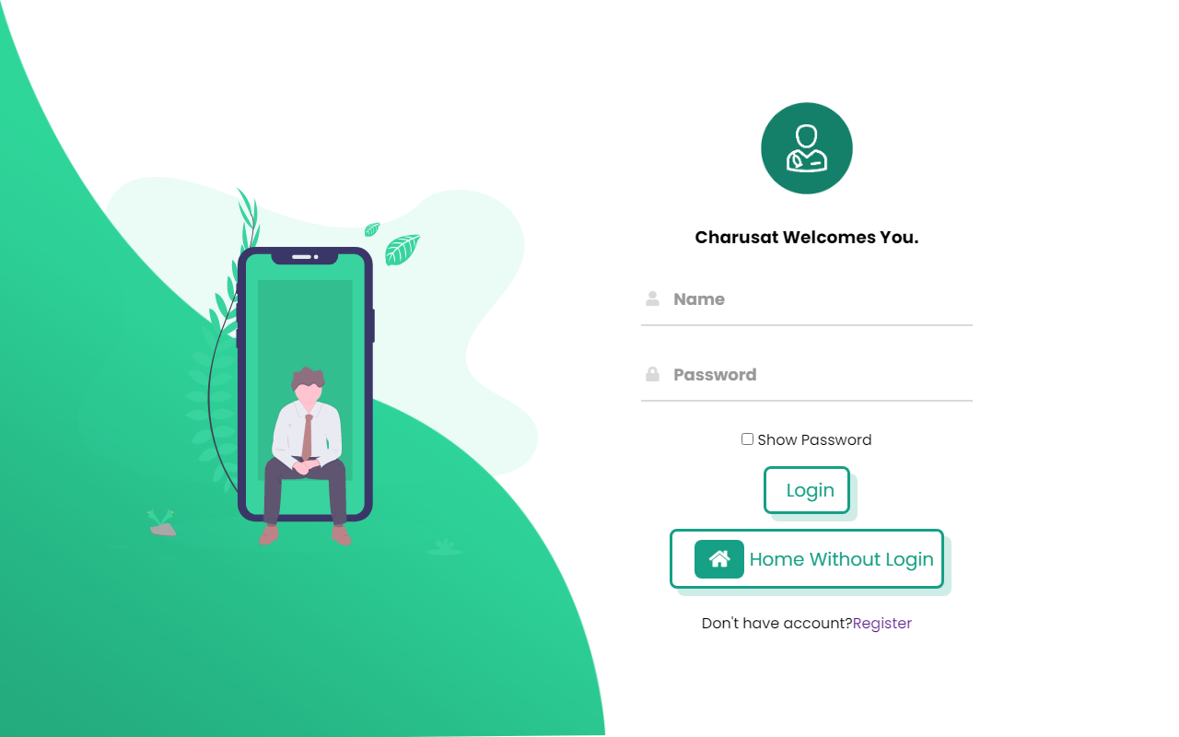

**6.2 Registration Activity**

**6.2.1 User Registration Page**

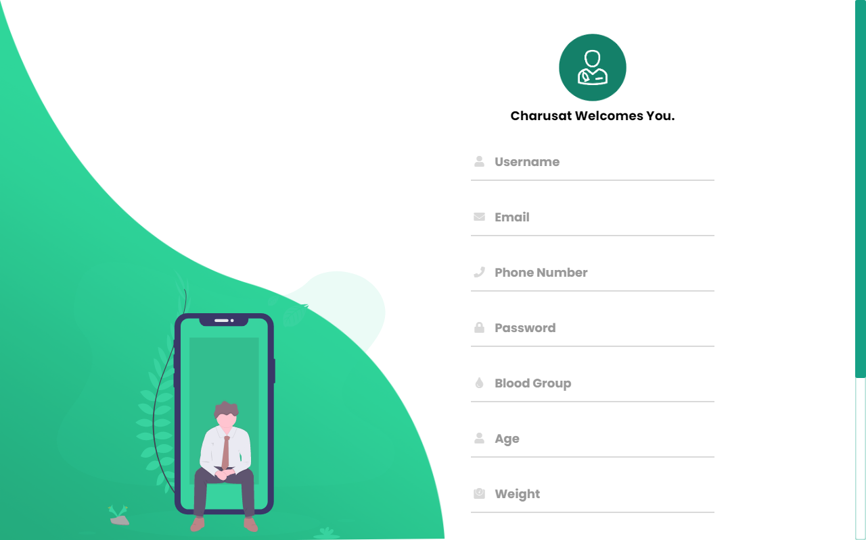

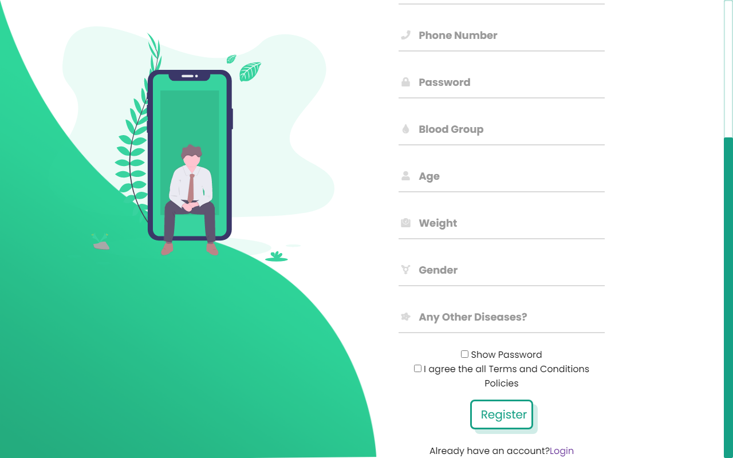

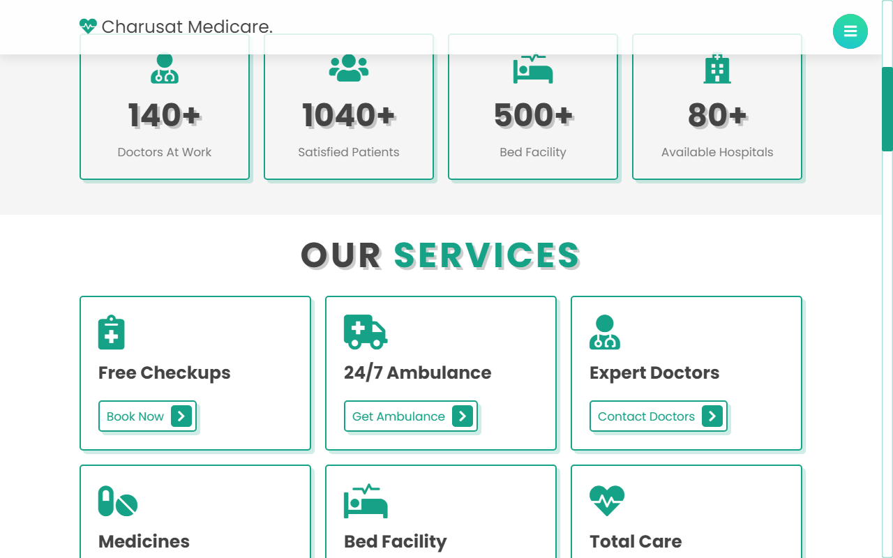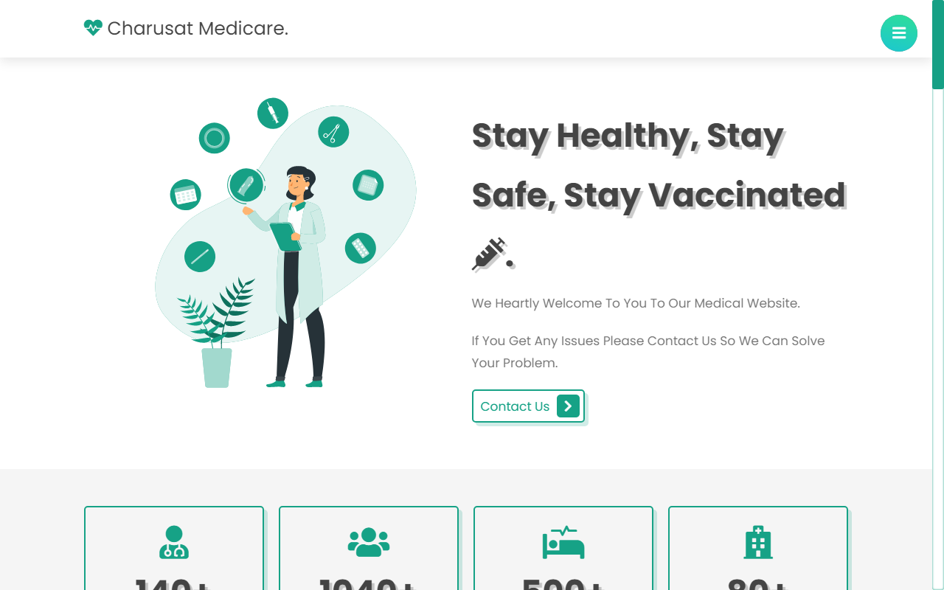**Home Page**

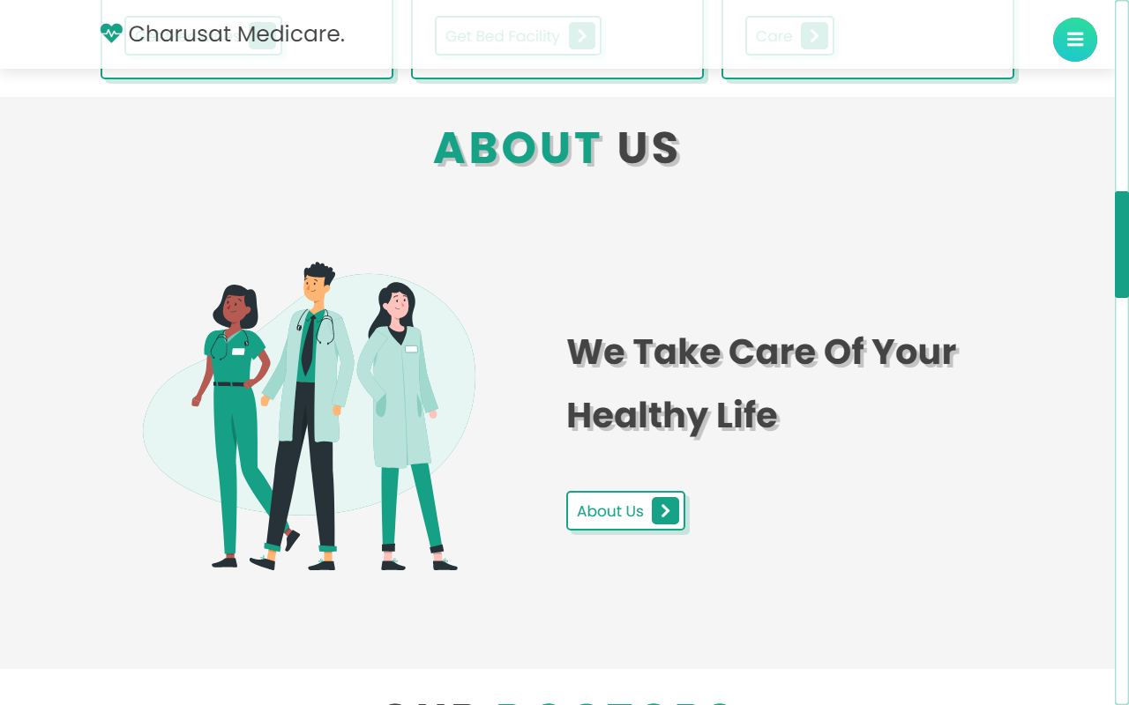

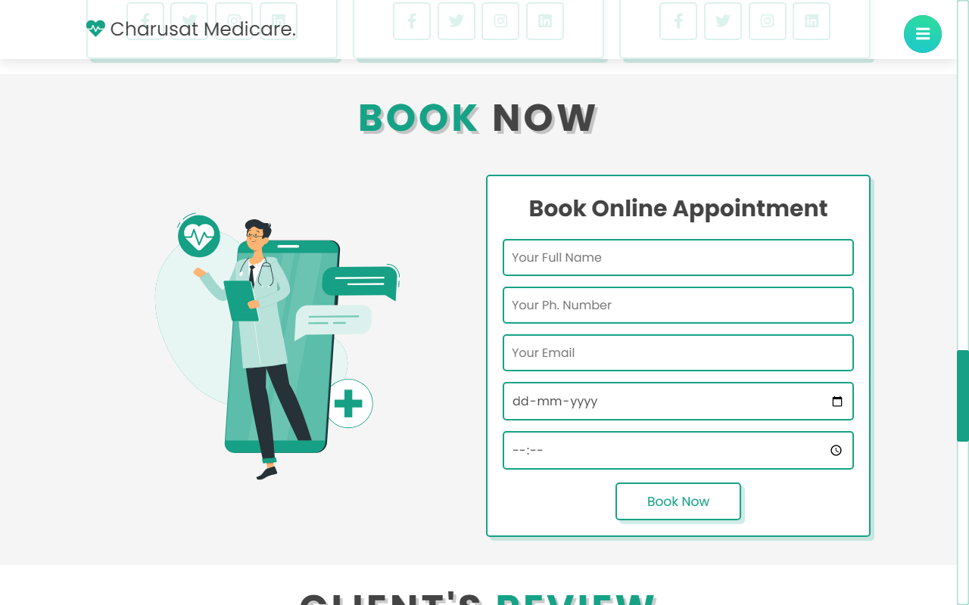

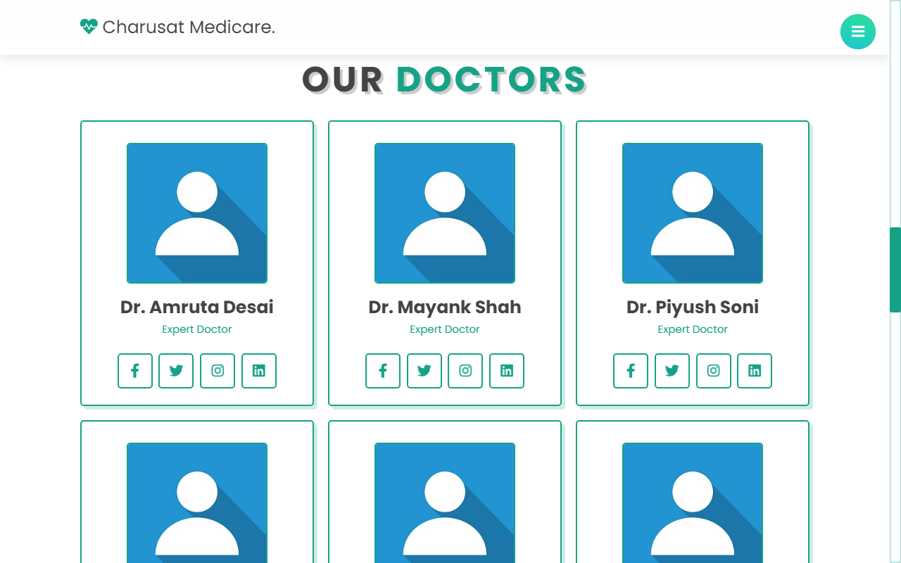

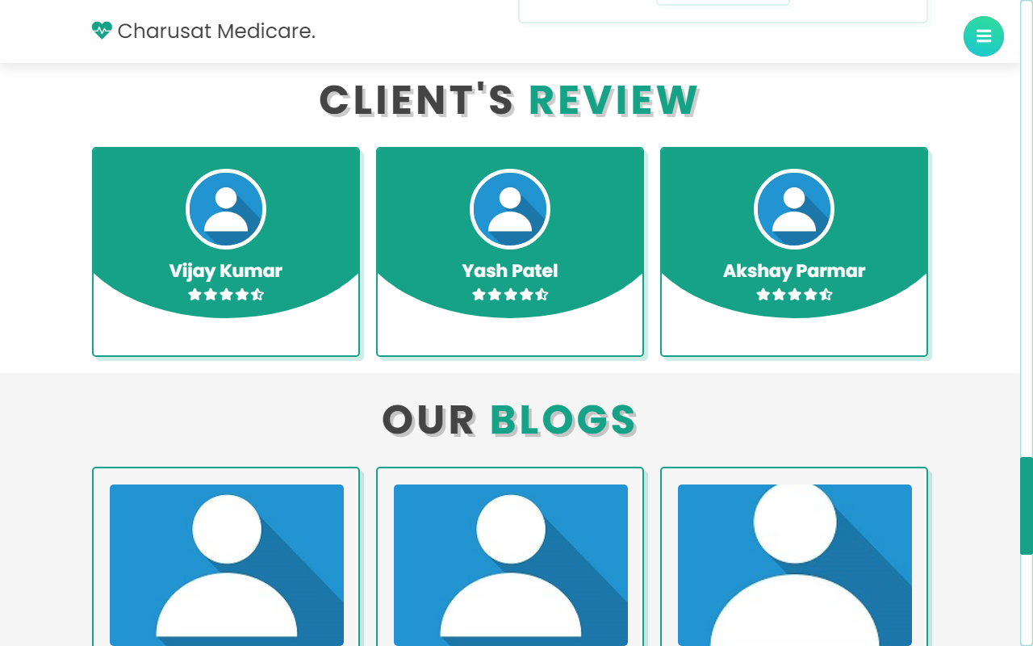

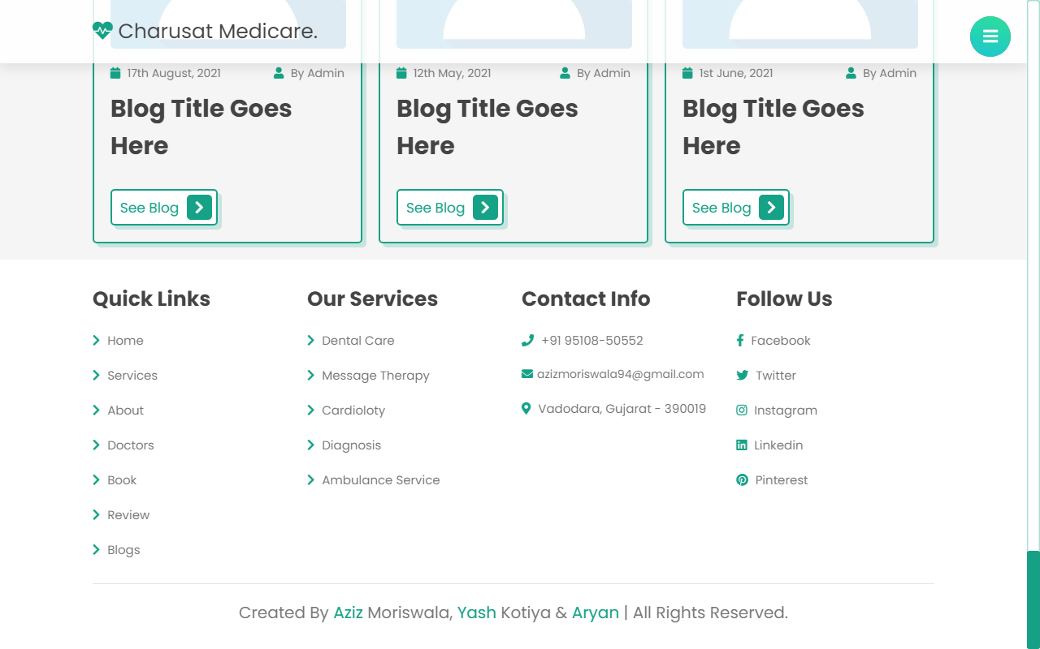

**Medicines**

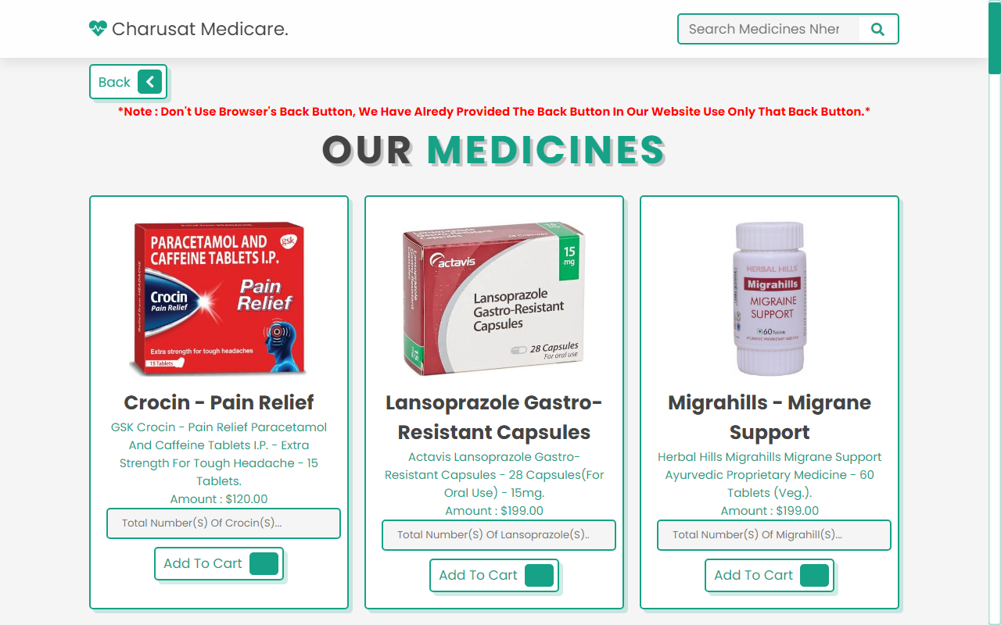

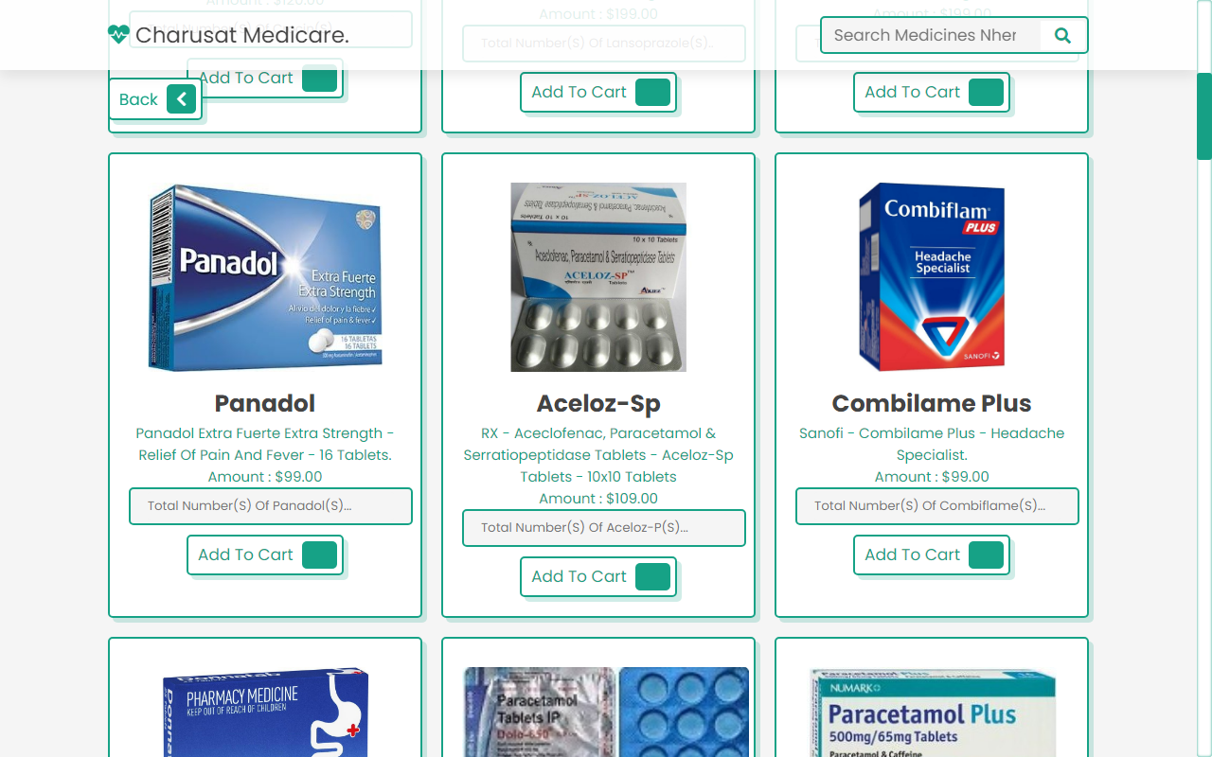

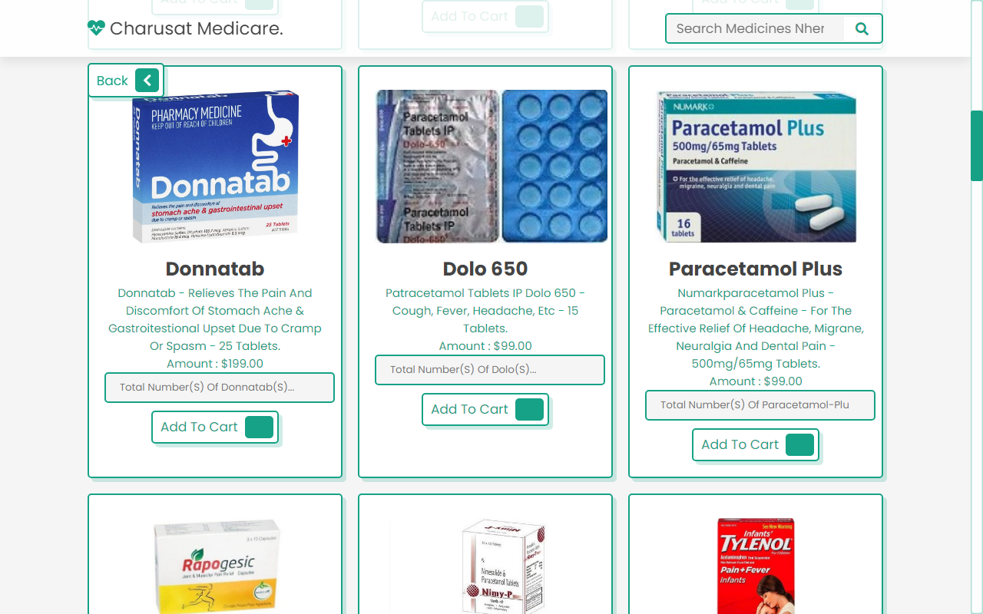

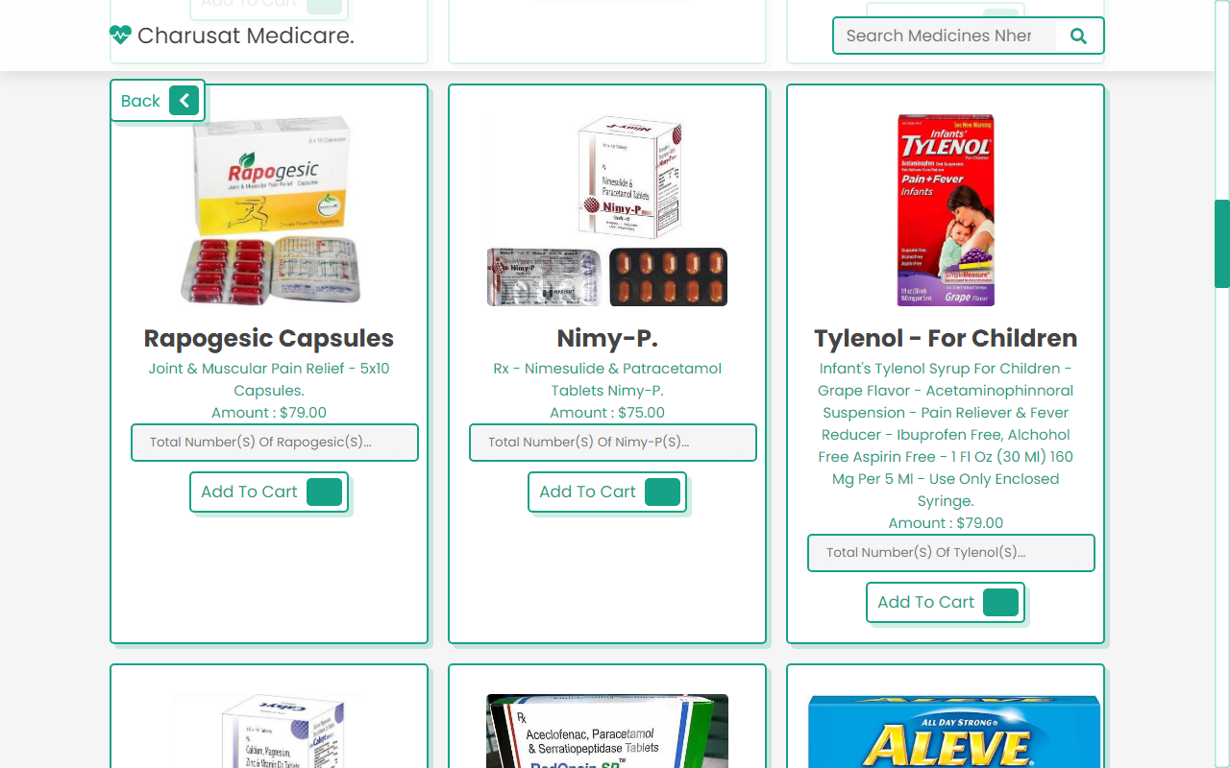

**Contact Us**

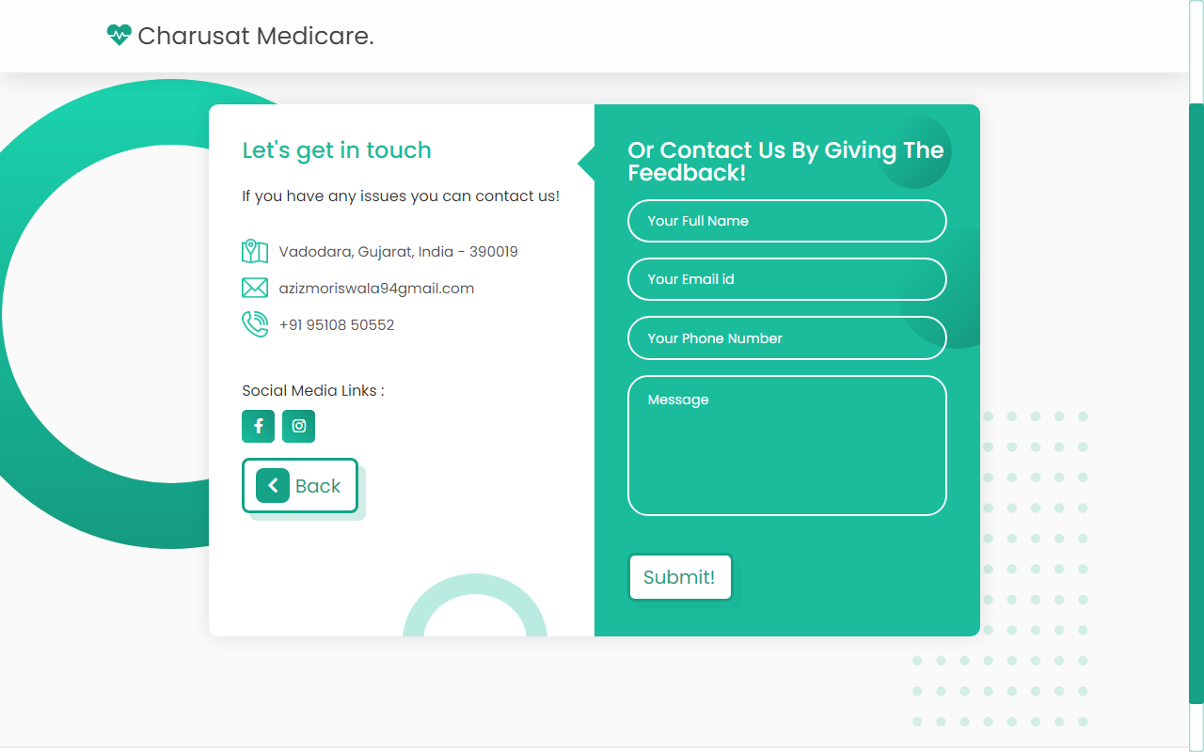

**FUTURE SCOPE**

**7.1 Limitations**

**7.2 Future Enhancement**

**7.1 Limitation**

* This project is web based, so performance depends on the Network speed & Traffic.
* Browser must be updated.
  1. **Future Enhancements**

#### This Project can be vast scope in the future. The can be implemented on internet in future. Project can be updated in future as and when the requirment for the same arises, as it is very flexible in ters of expansion. With the proposed software of database space manager ready and fully functional the client is now able to manage and run much better, accurate an error free manner. The developer can also use biometrics for customers to login in the web application, so this will be very helpful for future generations.

**CONCLUSION**

This web based software is efficient in maintaining patient’s details, and get the medicines in low prices and with fast delivery to all the patients. In conclusion, we need a healthy lifestyle to build up a healthy immune system and to avoid disease. Here, “maintain” means a healthy immune system to protect your body. To maintain body immunity. We should eat a variety of food and keep a balanced diet. The success of any of these applications depends on a variety of factors, including their cost-effectiveness, ease of use, and ability to improve on existing processes. While some applications are already being used in operational environments across networks other than the Internet, many represent new capabilities that have no parallel on other networks or that have not been fully implemented on a large scale, such as remote medical consultations.

#### BIBLIOGRAPHY

**Reference Books:**

1. Ian Sommerville (2010)
2. Visual Studio Code, By William Penberthy
3. Brackets
4. JavaScript Object-Oriented-Programming

**Website Reference:**

1. [www.w3schools.com](http://www.w3schools.com)
2. www.tutorialspoint.com
3. [www.youtube.com](http://www.youtube.com)
4. [www.javatpoint.com](http://www.javatpoint.com)